**Chemistry Unit 5 Compounds Name: ________________________________________ Solutions Worksheet**

Using the solubility curves below to solve the following problems. Use a ruler to determine the coordinates of a particular point on the curve.

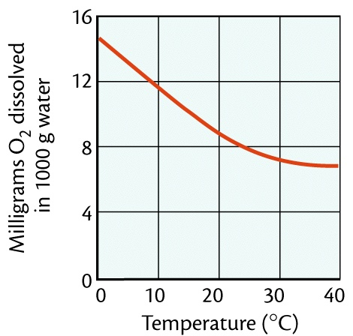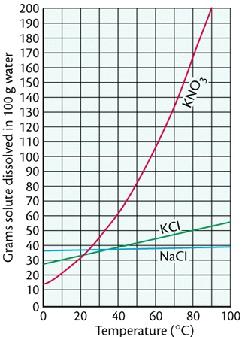

1. What is the solubility of potassium nitrate (KNO3) in 100.0 g of water at 80.0 °C?
2. What is the solubility of potassium chloride (KCl) in 100.0 g of water at 50.0 °C?
3. What is the solubility of sodium chloride (NaCl) in 100.0 g of water at 90.0 °C?
4. What is the minimum temperature needed to dissolve 180.0 g of KNO3 in 100.0 g of water?
5. What is the minimum temperature needed to dissolve 35.0 g of KCl in 100.0 g of water?
6. At what temperature do KCl and KNO3 have the same solubility?
7. How much more KCl will dissolve at 90.0 °C than at 20.0 °C? (Show work.)
8. If 50.0 g of NaCl is mixed with 100.0 g of water at 80.0°C, how much will not dissolve? (Show work.)
9. If 15.0 g of KCL is added to 100.0 g of water at 30.0 °C, how much more must be added to saturate the solution? (Show work.)
10. If a saturated solution of KNO3 at 20.0 °C is heated to 80.0 °C, how much more could be dissolved? (Show work.)
11. If a saturated solution of KCl at 90.0 °C is cooled to 30.0 °C, how much of the solid will precipitate? (Show work.)
12. How much NaCl will dissolve in 350.0 g of water at 70.0 °C? (Show work.)
13. How much KCl will dissolve in 50.0 g of water at 50.0 °C? (Show work.)
14. Classify as saturated or unsaturated a solution that contains 90.0 g of KNO3 in 100.0 g of water at 60.0 °C.
15. Classify as saturated or unsaturated a solution that contains 50.0 g of KCl in 100.0 g of water at 70.0 °C.
16. What temperature is needed to dissolve twice as much KNO3 as can be dissolved at 30.0 °C in 100.0 g of water. (Show work.)
17. What is the solubility of O2 gas in 1000.0 g of water at 24.0°C?
18. How much more soluble is O2 gas in water at 16.0 °C than at 40.0°C? (Show work.)
19. At what temperature is the solubility of O2 gas 10.0 mg in 1000.0 g of water?
20. What mass of O2 gas can be dissolved in 2000.0 g of water at 30.0 °C? (Show work.)